Name:P.Gayathri
Reg.No:192424324

18.Write a Prolog program for a database with NAME and DOB.
Aim
To write and execute a Prolog program to create a database containing names and dates of birth and retrieve the required information using queries.
Algorithm
- Start the program.
- Define facts containing the person's name and date of birth.
- Represent the date of birth using day, month, and year.
- Define a rule dob/2 to retrieve the date of birth.
- Enter a query with a person's name.
- Match the name with the database.
- Retrieve the corresponding DOB.
- Display the result.
- Stop.
PROGRAM:
% Prolog Program for a Database with NAME and DOB
% Database
person(rahul, 15, 3, 2003).
person(priya, 22, 7, 2004).
person(anu, 10, 1, 2002).
person(kiran, 18, 9, 2003).
person(sneha, 5, 12, 2004).
% Rule to find the date of birth
dob(Name, Day, Month, Year) :-
person(Name, Day, Month, Year).
INPUT:
dob(rahul, Day, Month, Year).
OUTPUT:
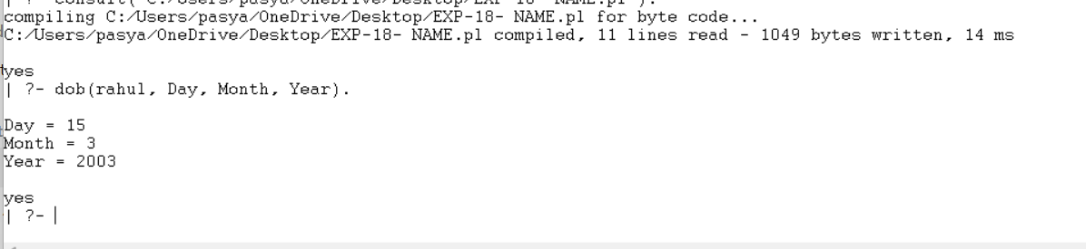

Result
Thus, the Prolog program was successfully executed to create a Name and DOB database and retrieve the required details.

